Order Your

USA Haidong Gumdo Association 2026 Championship Apparel!

- Go to rtgstores.com

- Click “Register for Access to RTG Stores” in red box

- Fill in your information, click “Collections,” enter this code: GUMDO

- Go to home page, click “Collections” as shown below
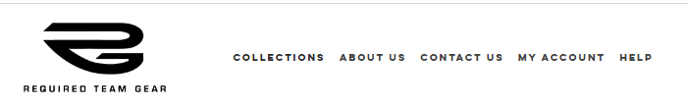

- Click on this icon below to shop

All items are “made-to-order” - expect to receive your order within 2 weeks of order date unless otherwise indicated.
Please place your order by July 1 at the latest to ensure it arrives before the team leaves for the Championship!

For questions or problems, contact Kellye@requiredteamgear.com or call my direct line: 817-754-7152

